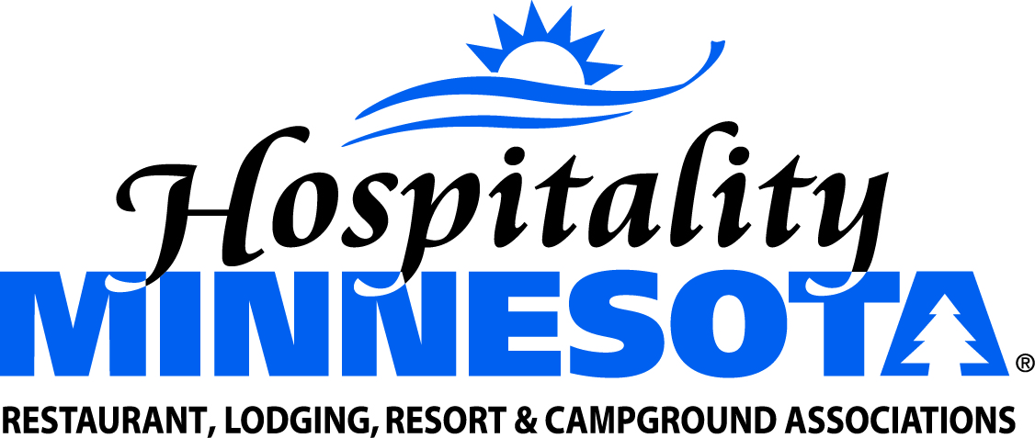

Create a State Income Tax Credit for Prepared Food Donations

POSITION: Hospitality Minnesota supports legislation to establish a non-refundable tax credit for the donation of prepared foods to charitable institutions such as food banks.

BACKGROUND: While federal tax law provides an enhanced deduction for the donation of ready-to-eat food to a recognized charity, Minnesota has not created a similar program at the state level. The proposed legislation creates a new tax credit to encourage businesses that prepare food for sale to donate surplus food to food banks and other recognized charities.

SUPPORTING STATEMENTS:
- Prepared food can go to waste for a variety of reasons. A snowstorm, for example, may reduce the number of people attending a special event or banquet, resulting in dozens or even hundreds of unserved meals.
- Many soup kitchens and feeding sites utilize locally donated restaurant food to supplement the meals they prepare. Restaurants are uniquely situated to combat hunger in this arena because of their business model of serving prepared food for immediate consumption.
- There is a cost to a business to properly package, refrigerate and document food to be given to a recognized charity.
- Food donation programs reduce greenhouse gas emissions by ensuring surplus food is kept out of landfills and waste combustion.
- Charities such as the Salvation Army and Second Harvest Heartland can make good use of donated ready-to-eat foods.

