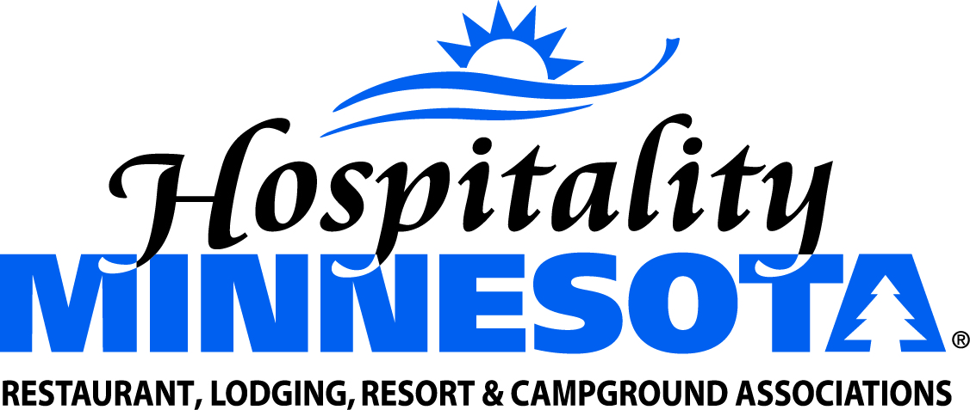

Exempt Restaurant Equipment from the Sales Tax

POSITION: Hospitality Minnesota supports exempting foodservice businesses from the state and local sales tax on capital equipment used to produce taxable meals.

SUPPORTING INFORMATION:
- Minnesota state law presently provides a sales tax exemption for manufacturing equipment used to produce products that are later resold and taxed at the point of sale. Many of our members manufacture meals, which are then sold to the consumer and taxed at the point of sale.
- In an effort in the early 1990’s to address a budget crisis, restaurant equipment was excluded from the capital equipment sales tax exemption. There was no tax policy reason for the change.
- Foodservice businesses are the only category of manufacturers required to pay the sales tax on their equipment purchases.
- A sales tax exemption is fair, consistent and will likely lead to more investment in energy efficient equipment.

