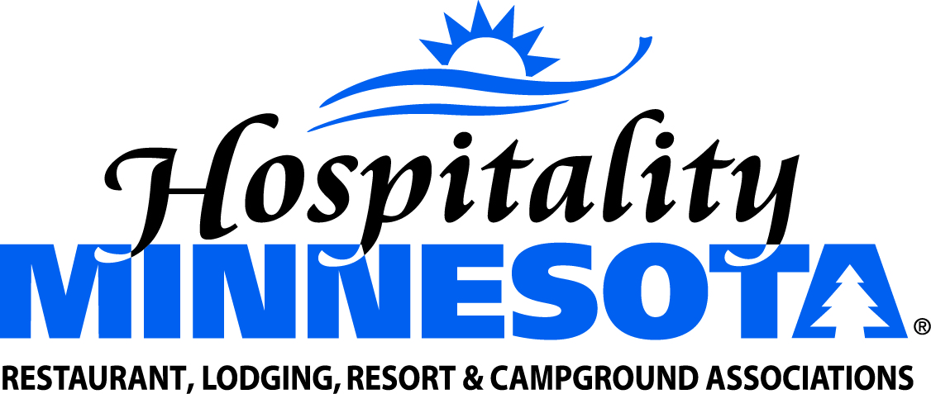
Oppose Mandatory Employer-Paid Sick and
Safe Leave or Unpaid Vacation

POSITION: The members of Hospitality Minnesota provide good jobs that contribute toward financial stability in our communities and across our state. However, we believe a single solution to labor issues isn’t reasonable, fair or realistic across all industries and business models.

There are numerous operational differences within the membership of our organization:
- Some entities have sharp seasonal peaks and make extensive use of part-time, seasonal and international workers.
- Some members employ high school and college-aged students working part time. They also employ adults working full time to support themselves, and adults working one to two shifts per week for extra spending money.
- It is a common practice for our employees to trade shifts when an illness or other reason precludes them from working.
We support industry best practices in achieving the goals of a healthy workforce that doesn’t lose hours or wages when ill. We also commit to continued dialogue with our employees to ensure their needs are met while continuing to operate successful businesses.

SUPPORTING STATEMENTS:
- Many members have paid sick leave or paid time off now. This practice is becoming more common as businesses compete for great employees.
- Employers should be allowed to craft their own sick time policies. The above points are just a few of the many different models in which members operate. We appreciate there are a variety of options for policies that work best for a variety of business models.
- Treating employees well is important to the success of any business. We want our employees to be healthy and to stay home when sick. We also want them to feel comfortable knowing they will still be able to pay their bills.

