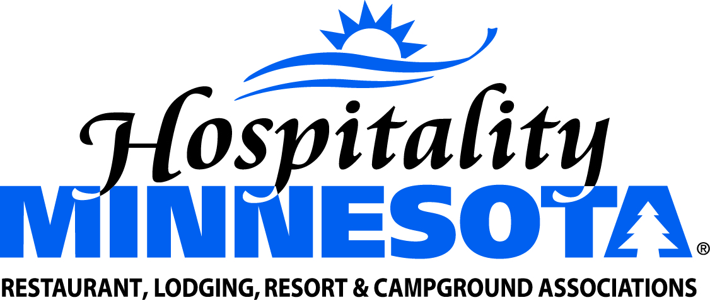
Increase Funding for Explore Minnesota
Position: Hospitality Minnesota supports an increase of $5.768 million to the base budget of Explore Minnesota. These funds will allow the state to compete with neighboring states in efforts to bring visitors and their dollars to Minnesota communities and attractions. Increased funding for Explore Minnesota should be directed to marketing and promotions activities. We also support an increase in the Event Grant Fund program to $1 million each year in the next biennium. These funds have proven to be popular for communities across the state and helped to bring several new community events to Minnesota.
Background: Tourism advocates have maintained a goal of making tourism a $20 billion industry in Minnesota by 2020. The current budget for Explore Minnesota lags well behind the budget of neighboring states and further limits our ability to compete for tourism dollars and travelers. Increased spending on marketing and promotions supports a wide variety of Main Street businesses and supports jobs across numerous sectors.
Supporting Facts:
- Minnesota Tourism is currently a $15 billion industry, supports 265,000 full and part-time hospitality and leisure jobs paying $5.4 billion in wages in communities across the state. Minnesota Tourism generates nearly 18% of all state sales tax collections. Tourism spending creates jobs, drives spending and has a positive return-on-investment.

- A 2016 report prepared on behalf of the Minnesota Office of Tourism assessed the economic impact of their advertising dollars spent in 2016. The study concluded for every $1 invested in their campaign, $98 in visitor spending was generated along with $9 in tax revenue benefit to Minnesota residents.

- A second study by the Minnesota Office of Tourism and their Spring/Summer 2016 Tourism Ad Campaign identified the following positive economic benefits:
- The ad campaign generated 3.5 million trips to Minnesota, resulting in $389 million in additional traveler spending.
- Including indirect and induced impacts, this ad campaign promoting Minnesota generated $51.9 million in state and local taxes and $47.6 million in Federal taxes.
- Travel-driven state and local tax proceeds of $51.9 million helped offset the average household tax burden by $24 per household. That is, were it not for the 2016 tourism ad campaign, Minnesota households would need to pay $24 each to maintain the same level of government revenue.

