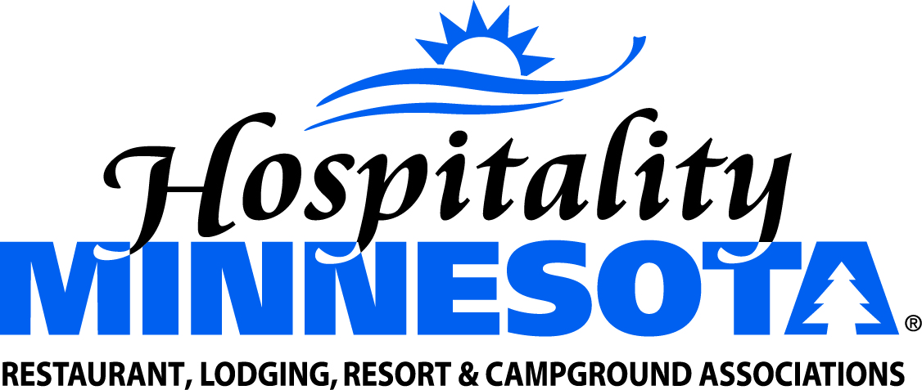
Support a Clarification of Local Taxing Authority

POSITION: Hospitality Minnesota supports legislation which clarifies existing Minnesota Law that limits local units of government from imposing a new tax on sales or income.
BACKGROUND: No local units of government in Minnesota have such a tax now. However, efforts on behalf of some groups across the country make it necessary to clarify this area of law to ensure the private sector and local units of government don’t end up in expensive battles in areas where the legislative intent can be made clear. The change makes it is very clear local units of government cannot tax any item that falls under the definition of food or the containers they come in.

SUPPORTING STATEMENTS:
- It has been shown that this class of taxes—imposed at the local level—has a negative impact on state revenues that rely on sales taxes imposed on the same products.

- Cities across the country have been inundated by outside interest groups pushing them to pass product-specific taxes. The outside pressure is often unwanted by city leaders and not supported by local citizens.

- This bill will protect local officials from outside pressure groups lobbying for taxes that have a dubious legal basis.

